Preface

This Guide explains how to use the departmental limits application to set up the credit risk categories and limit structures used to check credit line utilisation and to monitor your bank's exposure. It assumes that you are familiar with the basic principles of trade finance relating to credit risk management, and with web browsers.

# Introduction

This chapter provides an overview of the departmental limits application, explaining how it is used to define different categories of business risk and to set credit lines for individual customers, customer groups and countries. It also introduces some terminology used throughout the rest of this Guide.

## How the Application Works

The departmental limits application provides a way for the users to monitor their exposure against individual customers, groups of customers who are part of the same business hierarchy, and against countries. It also interacts with the system to carry out on-line limit checking for transactions as they are entered.

The departmental limits application permits you to define the basic categories of risk to be used in credit limit checking, using as criteria the different characteristics of the postings generated by the transactions. You may, for example, define one category of risk for sight letters of credit, and another for usance. For each category you can set a weighting to determine what percentage of the value of each exposure item belonging to that category is to be considered as risk.

You can also set up exclusion categories, which identify items which, for the purposes of the limit structures in which they are used, are to be considered as involving no risk. You can also set up total lines to record and monitor utilisation for sub-sets of the categories.

You then organise these categories and total lines into limit structures, which you can assign to one or more customers, customer groups and countries. Each limit structure identifies all the categories of risk you typically expect transactions for the customers, customer groups or countries for which it is set up to involve.

Limit structures also include a grand total line, which is used to record and monitor utilisation for all categories of risk included in the limit structure.

As you assign a limit structure to a particular customer, customer group or country, you can define, for that particular customer, customer group or country:

* Which categories of risk and total lines are to be used to record credit utilisation on reports and enquiries.
* Which categories of risk and total lines are to be used for on-line limit checking as transactions are entered into the system.
* For categories and total lines to be reported and/or checked, and for the grand total line, the limits against which monitoring and/or checking is to take place.

## Customer Group Hierarchies

Some of the customers on your database are likely to belong to the same business organisation - one customer may be a subsidiary of another, for example, or may be a member of the same business group as other customers. In such cases, more complex credit management, allowing you to check the cumulative utilisation resulting from transactions entered for customers belonging to the same legal entity, is required.

Customer groups can be used to identify those customers that are to be considered together for risk management purposes, and are normally used to identify customers as belonging to the same legal entity.

Further, you can define one such customer group (consisting of one or more customers with the same customer group) as a subsidiary of another such customer group. This is done within the departmental limits application by associating the customer group of the subsidiary with the customer group of the parent.

Using customer groups, you can therefore define the hierarchical relationships between customers of your bank who belong to the same business organisation.

Since you can set limits for customer groups as well as individual customers, you are able set limits at each level of a business hierarchy of this sort. As transactions for individual customers who are members of the same business hierarchy are entered, as well as being checked against their own limits, they will also be checked against the limits of their customer group, of the parent group, and so on, right up to the principal group at the top of the business hierarchy.

You can use different limit structures for customers and customer groups within a hierarchy to measure utilisation against different categories of risk, and you can omit limit checking completely at any level.

## During Transaction Processing

During either the Log or the Input step of an event (depending on how your system has been configured) a limit check and a reservation may be requested. This allows a portion of the customer's limit to be reserved until the transaction is complete. The departmental limits application checks the limit availability for the customer and, if relevant, for all customer groups in the business hierarchy to which the customer belongs. The application will also check limits for the customer's country and, optionally, for the countries of any customer groups in the hierarchy.

1. The system will only check country limits for customers and customer groups that have limits set up against them.

The limit reservation request is based on details on the postings that are generated as part of an event. Using the system tailoring application, each liability posting for which a limit check and reservation is required is identified as part of the posting definitions for the event. These postings may take one of two forms:

* Postings across customer accounts
* Postings across accounts associated with xPnnn system parameters where a related party is also supplied. The exposure is recorded against this related party

Using the information passed from the system, the reservation amount is checked against each credit risk category, and allocated to the appropriate credit line for each customer, customer group or country. Details of the limits affected and of the reservations effect on those limits are returned to the system. Depending on how your system is configured, an Approval step may be generated, allowing the account manager the opportunity to review credit line utilisation and to decide to approve or reject a transaction.

When the event is released, the actual postings themselves are then passed to the departmental limits application, matched against any associated reservation and recorded as exposure items.

Reservations immediately affect the exposure and availability for a customer, its country, and the related customer group hierarchy. Risk is not updated until the associated the transaction is released and the postings are received, resulting in the recording of new exposure items.

1. When implementing DL, the DL rebuild process should be scheduled in the EOD. Run a full EOD before issuing DL requests otherwise, it will return with a response indicating that the limit service is not available.

### Currency Conversions

Whenever the departmental limits application needs to carry out currency conversions - for example, because a reservation request is not in the limit currency - it uses yesterday's spot exchange rates, which are saved as part of overnight processing. All exposures are also revalued using these rates as part of end-of-day processing. This ensures that the amounts used by the departmental limits application are always consistent.

## Monitoring Exposure

The departmental limits application includes a suite of reports and enquiries which can be used to monitor limit utilisation. All utilisation reports and enquiries show:

* Exposure, which is the outstanding netted balance of debits and credits for a given risk category
* Risk, which is the weighted exposure for the risk category
* Availability, which is the amount of a limit still available for use. The departmental limits system parameter Weigh Limits allows you to specify whether the calculated availability is to reflect the weighting percentage for the risk category or not

The limit enquiries permit you to display details of the limits and limit utilisation for a customer, customer group or country. For business hierarchies, within the same enquiry you can display information for any of the customer groups or customers in the hierarchy, and for any of the associated countries. Within this enquiry you can also display details of the individual items contributing to the exposure recorded within a particular credit risk category. For customer groups, you can also display details of the individual customers and customer groups contributing to exposure within a particular credit risk category.

A customer group hierarchy enquiry allows you to display details of the customers and customer groups within a business hierarchy, and of credit utilisation by individual customers within that hierarchy.

A reservation enquiry allows you to enquire on all outstanding reservations for a particular customer.

Reports delivered with the departmental limits application provide information on the departmental limits system options, customer group hierarchies, categories, limit structures and country tenors set up for your system, as well as on customer, customer group and country utilisation against limits.

## Overnight Processing

During overnight processing, exposure details are rebuilt for any customers, customer groups or countries for whom the underlying limit structures have been changed during the day. All exposures are also revalued using the final spot exchange rates for that day's processing. In each case, exception reports are produced showing limit violations that have occurred.

Options are also available to create default limits for customers who have no limit set up and to update country exposures only during the end of day phase.

# System Options, Customers and Countries

This chapter explains how to set system options that support the departmental limits application, how to exempt customers from limit checking, and how to set the tenor of a country.

1. In addition to the facilities described here, your bank can also configure the colours used to display items involving limit violations in enquiries. This is done using the style_ti_plus2.css file.

## Departmental Limits Application System Options

1. Before you can use the functionality described in this section to identify the limit structures to be used as default you must have set these up, as described Chapter 5.

The Limit Definition|Limit Options menu option opens a window that allows you to set up departmental limit application parameters and default values used when defining limits.

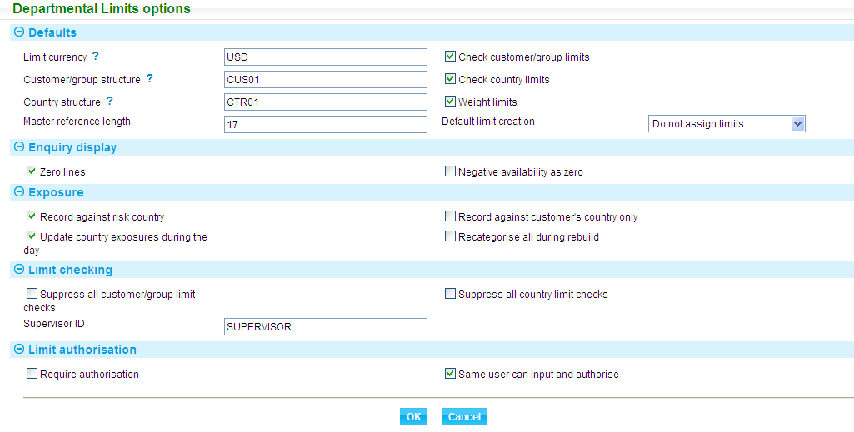

The Departmental Limits System Options report shows the current settings of the system parameters.

The following table explains what to enter into these fields:

|  | Field | What to Enter |
| --- | --- | --- |
|  | Limit Currency | The code of the currency to be used as the default when setting up limits against structures for customers, groups and countries. |
|  | Customer/Group Structure | The unique identifier of the limit structure to be presented as the default when setting up limits for customers and groups. This default limit structure is also used as the default for customers who have no limit structure defined if default customer limits are to be created during end of day. |
|  | Country Structure | The unique identifier of the limit structure to be presented as the default when setting up limits for countries. |
|  | Check Customer/Group Limits | This field determines the default value to be used in the Check Limits field when setting up limits for a customer or customer group. If you check this field, then the Check Limits field will also be checked by default. If you leave this field blank, the default is that limit checking will be suppressed for customers and customer groups. |
|  | Check Country Limits | This field determines the default value to be used in the Check Limits field when setting up limits for a country. If you check this field, then the Check Limits field will also be checked by default. If you leave this field blank, the default is that limit checking will be suppressed for countries. |
|  | Weight Limits | This field determines whether the weighting percentage entered against credit risk categories will be used when calculating the availability used when checking limits. If you leave this field blank, the weighting percentage will only be used when calculating risk.  If you change this setting after exposures have been recorded by the departmental limits application, all the relevant figures will be recalculated during the next end of day. |
|  | Master Reference Length | The master reference on reservations is used to set up a limit utilisation record. Exposures for the same transactions are grouped together when there is no event code present in the master reference. If the exposure has an event code, the length of the master reference can be set here so that exposures for the same transaction are grouped together. |
|  | Default Limit Creation | If you check this field, then, during overnight processing, the system will create default limits for any customer for which limits have not yet been defined, using the default limit structure identified above. The limit for each category or total line in the structure will be zero, causing any reservation against the categories of the default limit structure to return a limit violation message.  If a reservation is requested for a customer without limits defined, a 'No limits held' error message is returned, unless the customer belongs to a customer group that has limits defined. In this case, the system assumes limit checking is not required at the customer level, and no violation is reported.  This is intended to a cover a situation where you create a new customer on your trade finance database, but do not have the time to set up limits for them before overnight processing begins, or as a take-on utility when you first install the departmental limits application. |
|  | Zero Lines | Check this field if enquiries are to include information for risk categories and total lines even if they have no limit value assigned or no exposure amount.  By default this field is blank, meaning that enquiries will include information only for those categories and totals which have a limit value assigned, and have a non-zero exposure. |
|  | Negative Availability as 0 | Leave this field blank if reports and enquiries are to display limit breaches as a negative amount; check it to display limit breaches as zero instead. |
|  | Record Against Risk Country | Check this field if exposure is to be recorded against the customer risk country; leave it blank if exposure is to be recorded against the customer residence country. The setting of this field controls which country is displayed for customers throughout the departmental limit application's set-up and enquiry functions.  If you change this setting after exposures have been recorded by the departmental limits application, all the relevant figures will be recalculated during the next end of day. |
|  | Record Against Customer's Country Only | Check this field if exposure is to be recorded against the individual customer's country only; leave it blank if exposure is to be recorded against all countries involved in a business hierarchy.  If you change this setting after exposures have been recorded by the departmental limits application, all the relevant figures will be recalculated during the next end of day. |
|  | Update Country Exposure During the Day | Check this field if country exposure is to be updated as transactions are entered during the day; leave it blank if country exposure is to be updated during end of day instead.  If you change this setting after exposures have been recorded by the departmental limits application, all the relevant figures will be recalculated during the next end of day. |
|  | Recategorise all during rebuild | Check this field if you require all reservations and exposures to be recategorised during end of day. This flag is set off after the rebuild has completed. |
|  | Suppress All Customer/Group Limit Checks | This field controls whether limit checking is to be carried out for customers and customer groups. Check the field to suppress limit checking for all customers and groups. |
|  | Suppress All Country Limit Checks | This field controls whether limit checking is to be carried out for countries. Check the field to suppress limit checking for all countries. |
|  | Supervisor ID | This must be the same identifier as entered against the Supervisor ID field using the security application. |
|  | Require Authorisation | Check this field if any amendments to, or deletion of, limits set up for a customer, group or country must be authorised before they take effect. |
|  | Same User Can Input and Authorise | Check this field if the same person who made an amendment is also allowed to authorise it. If such amendments must instead be authorised by a second person, leave the field blank. |

## Exempting Customers from Limit Checking

When setting departmental limits system options (see the previous section) the Suppress All Customer/Group Limit Checks field can be used to suppress limit checking for all customers and customer groups. This enables you to activate limit checking by country only, while recording exposures for customers and customer groups.

You can suppress limit checking for individual customers and customer groups as part of the limit definition.

You can also suppress limit checking for customers by customer type. Use the Static Data|General|Customer Types link. The system displays a window which lists all customer types set up on the database.

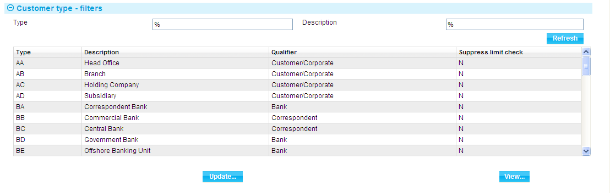

The window lists each customer type's unique code and description. Use the filter fields in the usual way to limit the display to certain customer types only.

To exempt customers of a certain type from limit checking, select the appropriate entry in the window, then click the **Update** button.

### Updating the Customer Type Setting

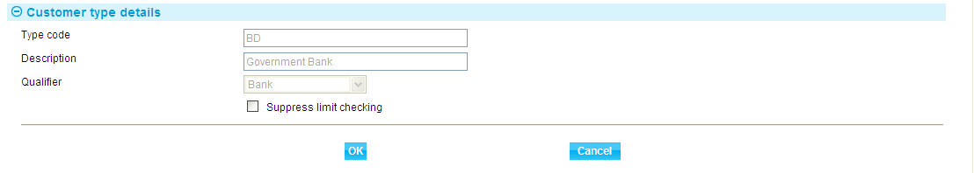

Check the Suppress Limit Checking box to suppress limit checking for customers of that type. (You can also uncheck the box to re-activate limit checking for that customer type, if it has already been suppressed.)

The setting takes effect immediately.

The Customer Type Details report shows which customer types have limit checking suppressed.

During transaction processing, the system will initiate limit checking, regardless of who the customer is. However, the departmental limits application will not perform limit checking if limit checking is suppressed for that customer in any of the ways described in this Guide.

## Exempting Countries from Limit Checking

When setting departmental limits system options (see page 5) the Suppress All Customer/Group Limit Checks field can be used to suppress limit checking for all customers and customer groups.

You can suppress limit checking for individual countries at the limit details level.

When setting up credit risk categories, you can use the tenor of a country as a selection criterion. You would use this facility if you want to define categories as involving, for example, short and long term risk, where the number of days that constitutes short or long term risk differs from country to country.

If you wish to have risk categories with a fixed number of days, or you wish to have more than two tenor periods, you can use the standard risk category selection criteria.

The tenor associated with a country is set within the departmental limits application using the Static Data|Country|Countries Tenors link.

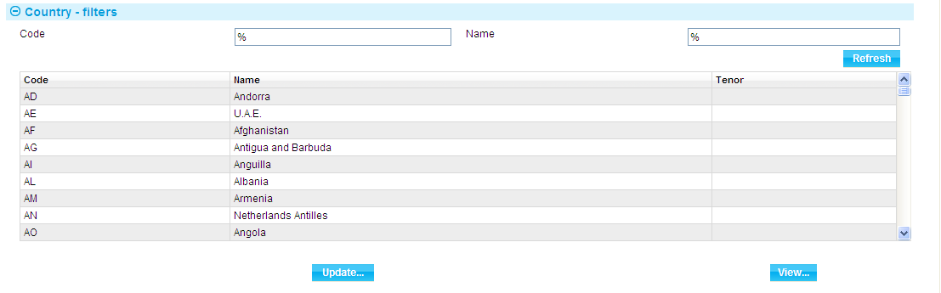

The system lists all the countries set up on your system, showing their unique code and description. Use the filter fields in the usual way to limit the display to certain countries only.

To set the tenor for a country, select the appropriate entry, then click the **Update** button.

### Updating the Country's Settings

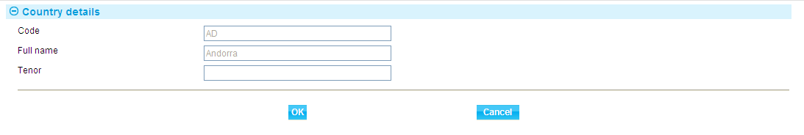

Use the tenor field to enter the number of days tenor for that country. If you change the tenor of a country once transactions have been recorded for that country, existing exposure will be recategorised during the next end of day.

# Customer Groups, Business Hierarchies and Credit Lines

This chapter explains how to define the relationships between customers of your bank who are part of the same business hierarchy using the customer group setting. It covers also assigning countries and account officers to customer groups.

The Group Details report provides information on customer group hierarchies.

## Overview

Some of the customers on your database are likely to belong to the same business hierarchy - one customer may be a subsidiary of another, for example, or may be a member of the same business group as other customers. Customer groups can be used to identify those customers that are to be considered together for risk management purposes, and are normally used to identify customers as belonging to the same legal entity.

For example, Arctic Oil Extraction and Eskimo Oil & Power Limited are both recorded as individual customers of your bank, but are actually divisions of a single organisation - North Sea Oil Canada. To reflect this relationship, you can set up a customer group with the unique identifier NSOCA and the description 'North Sea Oil Canada' and define Arctic Oil Extraction and Eskimo Oil & Power Limited as belonging to this group.

The following diagram illustrates this relationship. White boxes indicate the customers, the shaded one the customer group.



You can set up limits for the individual customers, and also for the customer group. Transactions entered for an individual customer can thus be used to accumulate utilisation totals for the individual customer and for the customer group to which they belong.

Where a customer group is a subsidiary of another customer group, you can define this hierarchy within the departmental limits application by associating the customer group of the subsidiary with the customer group of the parent.

For example, the customer group North Sea Oil Canada to which Arctic Oil Extraction and Eskimo Oil & Power Limited both belong is a subsidiary of North Sea Oil Western Operations, whose customer group has the identifier NSOW.

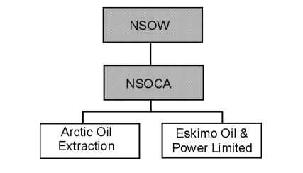

NSOW is the parent of NSOCA.

You can define limits at each level of this hierarchy so that transactions entered for the individual customers are used to accumulate utilisation totals for the individual customer, and for any customer groups in the hierarchy to which they belong.

As required, you can define limits for each level in a particular credit line, or at certain levels only. You can also use different limit structures at different levels, and thus record the credit utilisation associated with a transaction against different categories at different levels within the hierarchy.

This mechanism supports complex hierarchies and allows you to set up different credit lines for the same business organisation - each beginning with an individual customer - to reflect the relationships within that organisation. The hierarchy illustrated below, for example, provides credit lines for five customers on your database, each ending with the principal group at the top of the hierarchy.

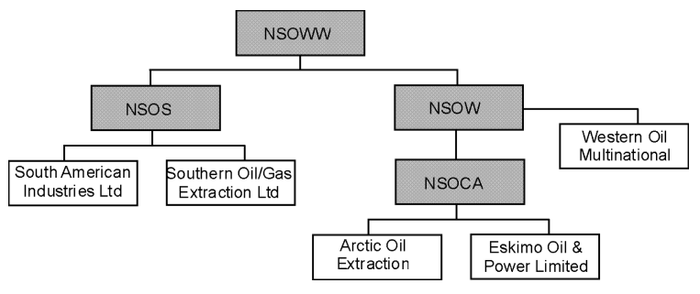

### Account Officers and Countries

For the purposes of credit limit checking, the departmental limits application permits you to assign an account officer and a country to customer groups.

Assigning a country to a customer group permits you, when checking limits and recording exposures, to record details against the group's country, if required.

Should a limit violation occur, the account officer setting identifies the individual member of staff (or department) responsible for the customer group, if this is different from the account officer for the individual customer.

## Arranging Customer Groups into Hierarchies

Select the Static Data|Customer maintenance|Groups link.

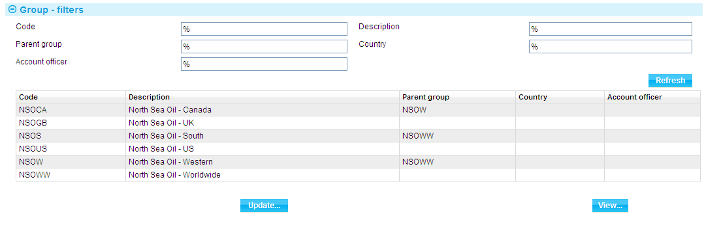

The window displayed can be used to list all the customer groups set up on the database alphabetically by customer group identifier. You can view or amend the details of a customer group hierarchy by selecting it and clicking either the **View** or the **Update** button.

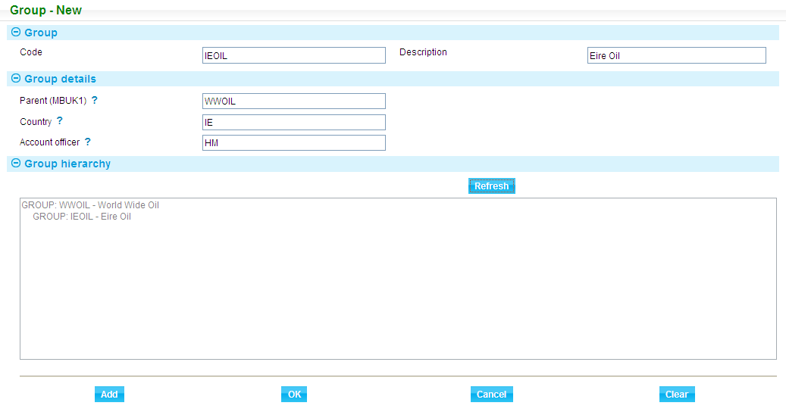

Use the browser buttons in the Group details pane to select the customer group's parent group, country and account officer. These fields are optional. Click **Add** to save the new group.

If you enter a parent group, when you click **Refresh** the system displays the hierarchy in the Group Hierarchy field.

# Setting Up Credit Risk Categories and Total Lines

This chapter explains how to use the departmental limits application to set up the categories and total lines used during limit checking to determine what type of credit risk a transaction constitutes.

Two reports are delivered with the departmental limits application - the Limit Categories report and the Limit Totals report - which provide information on the categories and total lines set up on your system.

## Credit Risk Categories

Credit risk categories are used to define transactions as involving a certain type of credit risk. Each category consists of a set of criteria which can be used to identify transactions with certain characteristics - for example, as being a particular type of trade finance product that represents a certain type of credit risk for your bank.

These categories are used to construct limit structures, which you can then assign to customers, customer groups and countries and set up limits for each category.

The risk associated with a credit risk category can be weighted so that only a percentage of the transaction amount is counted as credit line utilisation.

The departmental limits application is delivered with two credit risk categories already set up which are automatically included in all limit structures. These are used to accumulate the credit risk associated with transactions that do not match the criteria of any of the credit risk categories included in a limit structure. These are:

|  |  |
| --- | --- |
| UNCCT | For unclassified transactions involving contingent account postings. |
| UNCNC | For unclassified transactions involving non-contingent account postings. |

No exposure should normally be reported against the unclassified categories. If these unclassified categories should have exposure reported against them, you should review the limit categories and structure and make amendments to ensure that all items are categorised correctly.

### Exclusion Categories

You can define exclusion categories to identify transactions that are not to be considered as involving a credit risk. These are included in limit structures in the usual way, but at the very start of the structure, so that they filter out transactions not to be used to accumulate credit risk.

Because the system passes every posting affecting a customer account to the departmental limits application for categorisation, exclusion categories are very important. For example, an exclusion category is required for all settlement postings to avoid double counting.

As well as postings affecting customer accounts, the system passes to the departmental limits application every posting across accounts associated with xPnnn system parameters where a related party is supplied. The exposure will be recorded against that party. To prevent this, exclusion categories can be set up that cover all the internal account types used in the system.

### Total Lines

There may be circumstances in which you wish to record, monitor or check different credit risk categories together as well as at an individual category level. To do this, the departmental limits application allows you to set up total lines, in which each of the categories to be treated together is identified. Total lines are then included in a limit structure in the same way as categories.

## Defining Credit Risk Categories

Select the Limit Definition|Limit Categories menu option.

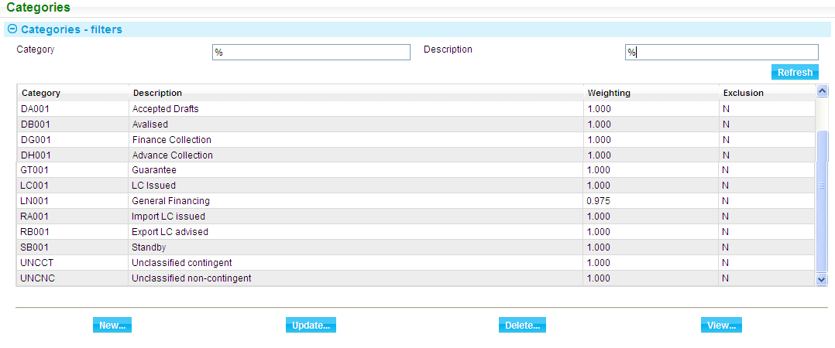

This window can be used to list all the credit risk categories set up on your system. You can add, view, amend and delete credit risk categories in the usual way. However, you cannot delete a credit risk category if it is being used in a limit structure.

To add a new credit risk category click the **New** button.

### Adding a New Category

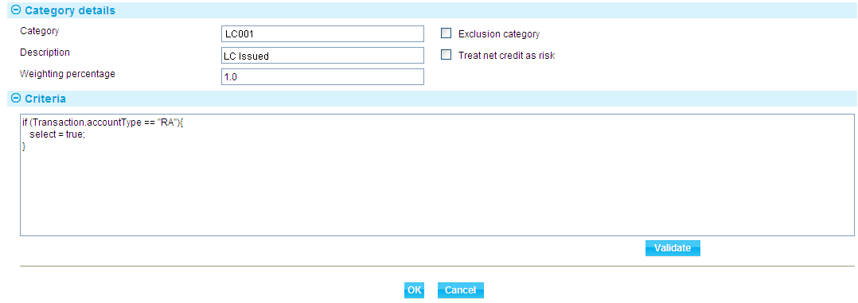

The following table explains what to enter into the fields in this window:

|  |  |  |
| --- | --- | --- |
|  | Field | What to Enter |
|  | Category | A unique identifier for the credit risk category. |
|  | Description | A description of the credit risk category. |
|  | Exclusion Category | Check this field if the category is an exclusion category. |
|  | Treat Net Credit as Risk | The system calculates the risk for a category by netting debits and credits. If you leave this field blank, a net credit result will be ignored; if you check this field, a net credit result will be treated as risk. |
|  | Criteria | Use this field to enter the criteria to determine which transactions are to be included in this category of credit risk. See the Appendix for information on the syntax used to set selection criteria in this window. |

## Total Lines

There may be circumstances in which you wish to record, monitor or check different credit risk categories together while recording utilisation for each of them separately. To do this, the departmental limits application allows you to set up total lines, in which each of the categories to be treated together is identified. Total lines are then included in a limit structure in the same way as categories.

You can also define total lines as including other total lines, as well as categories, allowing you to construct several levels of totalling within a limit structure.

Total lines are used in addition to the grand total line, which is always present at the end of limit structure.

To set up a total line, use the Limit Definition|Limit Totals menu option.

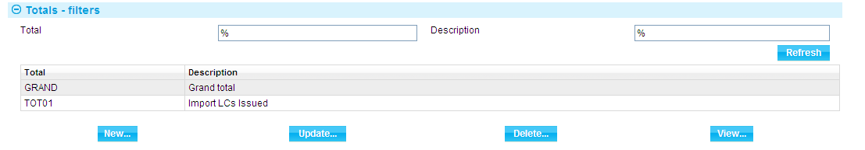

The window can be used to list all the total lines already set up on your system (including the grand total, which has the unique identifier 'GRAND'. Use the filter fields in the usual way to limit the display to certain total lines only.

You can add, view, amend and delete total lines in the usual way. However, you cannot delete a total line if it is being used in a limit structure, and for the GRAND total line you can only change the description.

1. Grand total does NOT have to be the total of the individual limits. This allows banks to set higher limits for individual business areas and at the same time define a lower overall exposure.

To add a new total line, click **New**.

### Adding a New Total Line

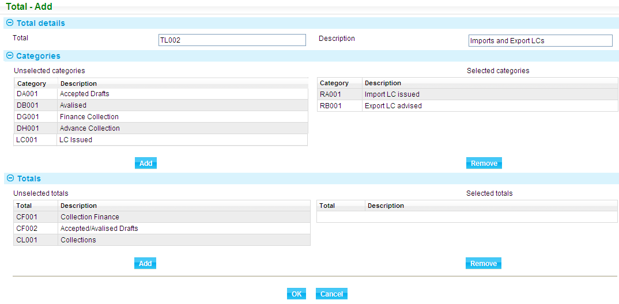

Enter a unique identifier (up to five characters long) into the Total field and a description into the Description field.

The Unselected Categories list shows all the credit risk categories, and the Unselected Totals list shows all the total lines already set up on your system. Select the categories and total lines you wish to include in the total line, then click the  button in the appropriate pane to select the required categories and total lines to be included in the total line you are defining. (The  button allows you to deselect items.)

# Defining Limit Structures

This chapter explains how to organise credit risk categories and total lines into the limit structures used to record, monitor and check credit utilisation.

The Limit Structures report provides information on the limit structures set up on your system.

## Limit Structures

Each limit structure is defined to be used either for customers and customer groups only, for countries only, or for both. Once set up, the limit structure can be assigned to any number of customers, customer groups or countries, as appropriate.

You can set up any number of limit structures, depending on your requirements. For example, you may decide to set up a single limit structure for use with all your corporate customers. Alternatively, you may instead set up different limit structures for different types of corporate customer.

A limit structure consists of one or more credit risk categories, sequenced in the order in which they will be used for categorisation when reservations or exposure items are received.

Limit structures also include a grand total line, against which the system records the total exposure recorded against each of the categories within the limit structure. You can also include total lines in a limit structure to record exposure for a sub-set of the categories within a structure. Again, you can set limits against these total lines for use in credit checking.

You can define categories, total lines and the grand total line separately:

* To be monitored, in which case, when setting up limits, you will be able to enter a limit against it which will be reported whenever exposure is reported. Any exceptions will be highlighted
* To be checked, in which case, in addition, you will be able to define that customer group and country limits are to be checked for limit violations when a limit check and reservation request is received from the system during transaction processing
* Not to be monitored, in which case reports and enquiries will show the exposure against the category without a limit being set up for it. No limit violations will be reported on departmental limits application reports and enquiries

### Exclusion Categories and Unclassified Categories

Limit structures will normally include exclusion categories, which identify postings that are not considered to involve exposure for the purposes of credit risk management.

Two categories are delivered with the departmental limits system and are used to record exposure for transactions that fail to match the criteria set for any of the categories.

### Some Considerations when Building a Limit Structure

When setting up a limit structure, place any exclusion categories at the start of the structure. Follow these by the categories in which transactions for the customers, customer groups or country to be assigned that limit structure are most likely to fall. Place the categories in which transactions using that limit structure are least likely to fall at the end of the limit structure. This speeds up limit checking by ensuring that each transaction is checked against as few categories as possible.

Bear in mind also that, if an individual transaction satisfies the selection criteria set up for several categories, it will be recorded against the first one the system encounters in the limit structure.

## Building a Limit Structure

To create a new limit structure, use the Limit Definition|Limit Structures menu option.

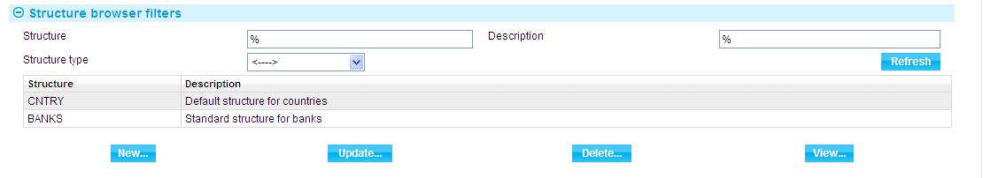

The window can be used to list all the limit structures already set up on your system. Use the filter fields in the usual way to limit the display to certain limit structures only. You can add, view, amend and delete limit structures in the usual way. Information on the effect of amending a limit structure is provided at the end of this chapter (see page 19).

To add a new limit structure, click the **New** button.

### Creating a New Limit Structure

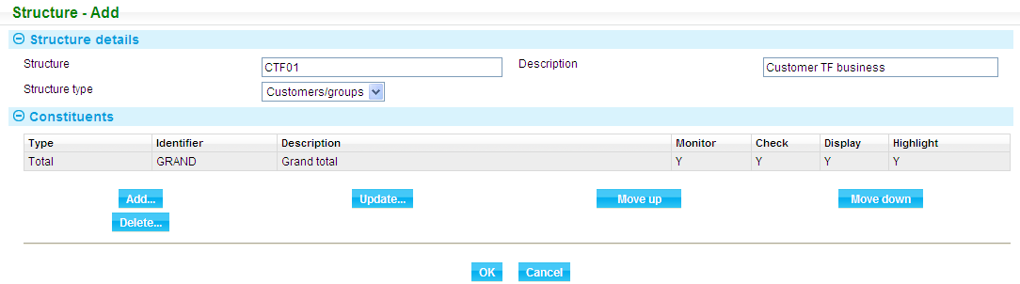

Enter a unique identifier (up to five characters long) into the Structure field and a description into the Description field.

Select a value in the Structure Type field to indicate whether this limit structure is for customers and customer groups only, for countries only, or for both.

The Constituents pane lists the grand total line for the limit structure, which is a mandatory part of the structure. You can add categories or total lines to the limit structure by clicking the **Add** button.

You can change the position of categories and total lines by selecting an entry and clicking the **Move Up** button to move it one place up, or the Move Down button to move it one place down. However, you cannot move the grand total line in this way - this is always the last entry in the limit structure.

You can remove a category or total line (but not the grand total line) by selecting it and clicking the **Delete** button.

To add a category or total line click **Add**.

### Adding Categories and Total Lines to the Limit Structure

Use the Entry Type field to select whether you want to add a category or a total line, then use the Total field to identify the actual category or total line.

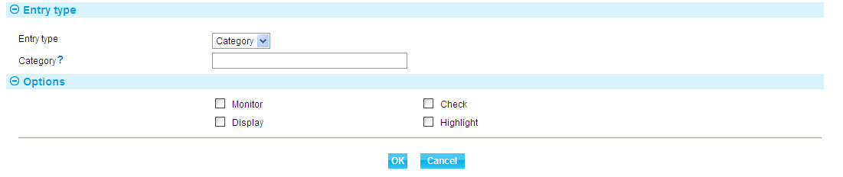

1. When you add a total line to a limit structure, you must ensure that the limit structure contains also all the categories used to make up the total line. If, when defining limits for customers or customer groups, a limit is to be entered against this category or total line and exposure reported against it, check the Monitor field. If the category or total line is eligible to be used to for limit checking during transaction processing, check the Check field.

Check the Display field if the category or total line is to be included in reports and enquiries, otherwise leave it blank. Check the Display field if the category or total line is to be displayed in bold in reports and enquiries.

Click the **OK** button to save. The window closes and the new category or total line is included in the limit structure.

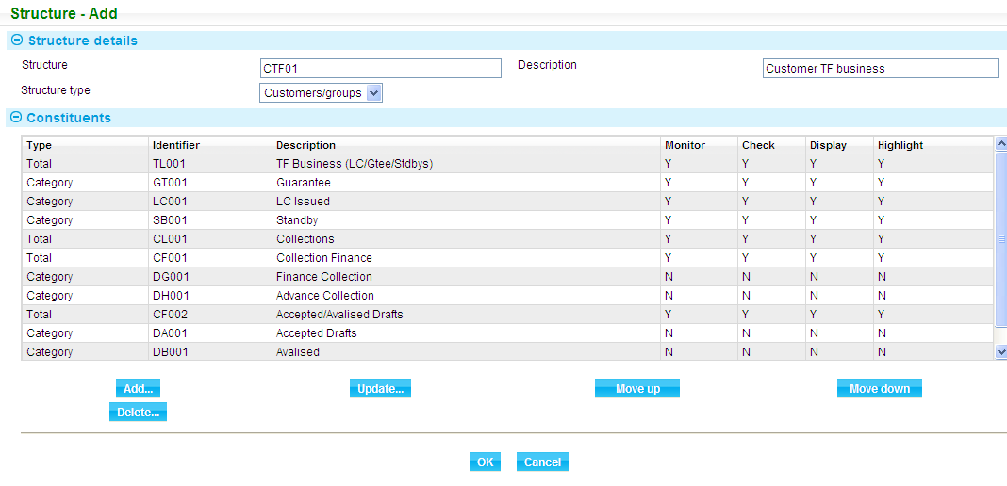

## Amending a Limit Structure Once it is In Use

Changes to an existing limit structure can be made at any time during business hours. This enables users to change a structure with the limit checking effects being noticed immediately.

If the limit structure has already been used to set limits for a customer, customer group or country and exposures already exist, they are recategorised using the updated limit structure only during the next end of day.

# Assigning Limit Structures and Setting Limits

This chapter explains how to use the departmental limits application to assign limit structures to customers, customer groups and countries and to set up limits for each of the categories and total lines, and for the grand total.

## Overview

Once you have set up the limit structures your system will use you can assign them to individual customers, customer groups and countries and enter a limit for each category or total line that is to be monitored for each individual customer, customer group or country.

At individual limit level, you can determine which limits are to be used for credit checking during transaction processing, set a different currency and expiry date for each limit, and give each line a status, using a value system defined by your own bank. This status is shown on reports and enquiries.

You can assign the customer, customer group or country limits a branch which can be used for reporting purposes.

If you have set up the departmental limits application so that amendments to limits require authorisation, then any new limits you enter and any amendments to or deletions of existing limits will not take immediate effect - any such actions will require authorisation.

1. You can amend the content of the Narrative field without authorisation being required.

Limits awaiting authorisation will be highlighted with shading on the Set Up Limits window. Provided you have the required capability, an extra button - the Authorise button - will be available. You can use this button to review the limits and then either authorise or reject them from within the Authorise Customer/Group/Country Limits Details window.

## Assigning a Limit Structure and Entering Limit Details

Select the Limit Definition|Limits menu option.

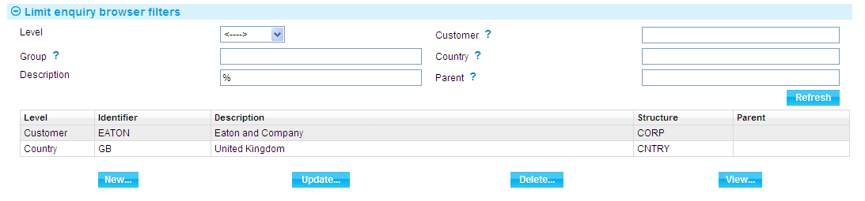

The window displayed can be used to list the customers, customer groups and countries to which you have already assigned a limit structure. Use the filter fields in the usual way to limit the display to customers, customer groups or countries that satisfy certain criteria.

Information is shown under the following headings:

|  |  |
| --- | --- |
| Heading | What it Shows |
| Level | Indicates whether this is a customer, a customer group or a country. |
| Identifier | The unique identifier for the customer, customer group or country. |
| Description | The customer, customer group or country's description. |
| Structure | The unique identifier of the limit structure assigned to the customer, customer group or country. |
| Parent | For customers and customer groups, the unique identifier of the parent customer group. |

You can add, view, amend and delete items in the usual way. If you delete an item the exposures database will be updated to reflect the deletion during the next overnight processing cycle.

If you wish to assign a different limit structure to a customer, customer group or country, you must first delete the existing assignment, and then wait until the next day before you can assign a new limit structure.

To assign a limit structure to a customer, customer group or country, click the **New** button.

### Making a New Assignment

Use the Limit Type field to select whether you want to assign the limit structure to a customer, customer group or country and enter the unique identifier of the customer, customer group or country.

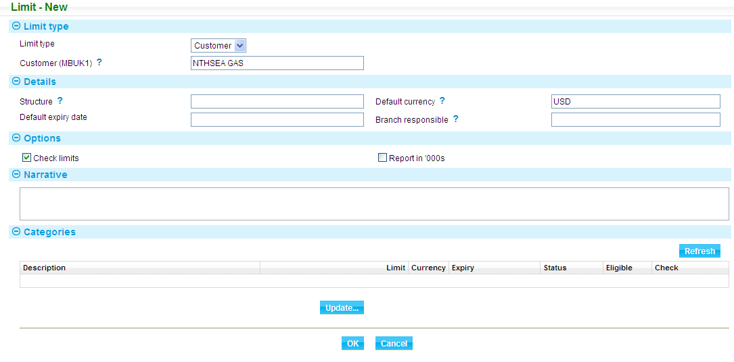

If you have already assigned a limit structure to that customer, customer group or country, the application produces an error message to that effect.

The following table explains what to enter into the remaining fields in this window:

|  |  |  |
| --- | --- | --- |
|  | Field | What to Enter |
|  | Structure | The limit structure to be used. The default - defined as part of the departmental limits system options - is displayed. |
|  | Default Currency | The currency to be used as a default for limits for this customer, customer group or country. The default - defined as part of the departmental limits system options - is displayed. If no default has been defined, then the base currency is displayed here instead. |
|  | Default Expiry Date | An expiry date to be used as a default for limits for this customer, customer group or country. If this field is left blank, then you must enter an expiry date against each individual line within the limit details. The expiry date is used during limit checking and for reporting purposes. |
|  | Branch Responsible | If relevant, the branch responsible for the limits you are currently setting up. Utilisation reports delivered with the departmental limits application are ordered by branch responsible. Any limits that do not have a branch responsible identified here are printed together in a separate section of the report. |
|  | Check Limits | Check this field if the default for the lines within the limit details is for limit checking is to be carried out for the customer, customer group or country during transaction processing. |
|  | Report in 000's | Check this field if amounts are to be shown in reports and enquiries in thousands of major currency units. If you leave it blank, amounts will be shown in minor currency units. |
|  | Narrative | A narrative concerning the limits and their use. This appears on limit utilisation reports and enquiries. This narrative is also included in the details returned to the system as part of the limit checking and reservation process. |

Once you have entered a limit structure, the system lists all the categories and total lines in the limit structure, together with the grand total line.

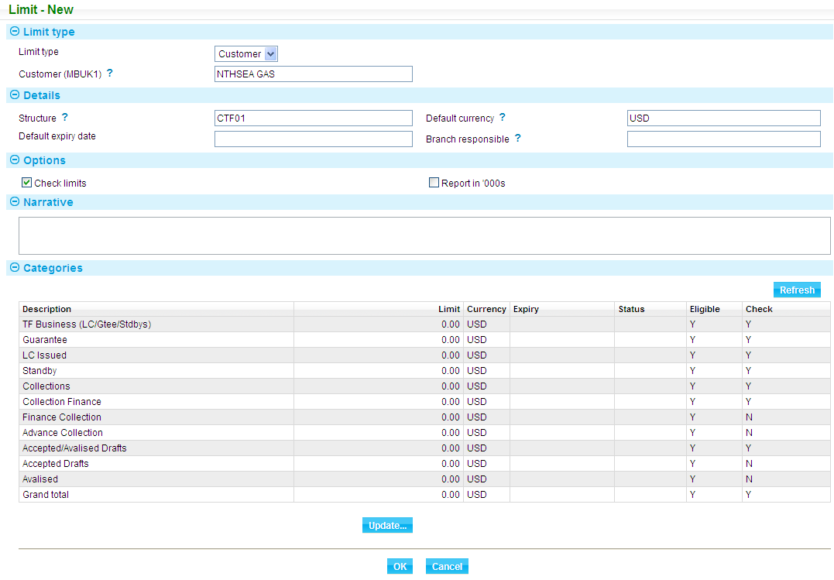

Information is shown under the following headings:

|  |  |
| --- | --- |
| Heading | What it Shows |
| Description | The category, total or grand total's description. |
| Limit | For categories and total lines that are to be monitored, the Limit column shows a zero amount; for exclusion categories and categories that are not to be monitored, the Limit column is blank. Once a limit has been entered, it is displayed here. |
| Expiry | The expiry date of this particular line. |
| Status | The status associated with the line. |
| Eligible | Indicates whether the customer, customer group or country is permitted to trade in this category of risk (Y) or not (N). |
| Check | Indicates whether the limit is to be used for credit limit checking during the transaction processing. This is available only if the category or total line on the underlying limit structure is set to be used to check limits. |
| Currency | The currency of the limit. |

To define the actual limit for a line for this customer, customer group or country, highlight the line and click the **Refresh** button in the Categories pane. You must do this for each line in the limit structure, as described in the next section. When you have set limits for each of the categories and total lines, click **OK** to save your input. Unless you have configured your system to require limit authorisation, the new limits come into immediate effect.

### Setting the Limit for a Line

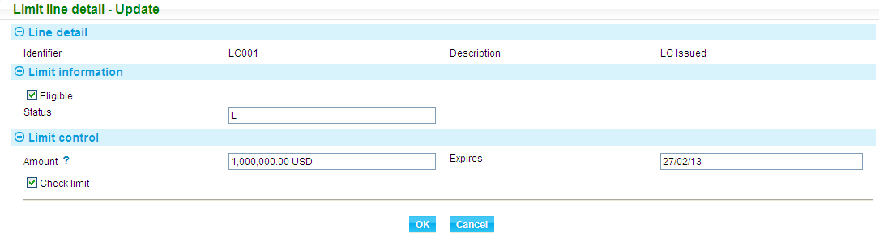

For exclusion categories and categories and totals that are not to be monitored, the Limit Control pane is not present.

The Line Detail panel shows the unique identifier and description of the category or total. The following table explains what to enter into this window to define the limit:

|  |  |  |
| --- | --- | --- |
|  | Field | What to Enter |
|  | Eligible | Check this field if the customer, customer group or country is to be permitted to trade in this category of risk. If you leave this blank, then any transactions entered for the customer, customer group or country that fall into this category will be reported as ineligible. |
|  | Status | If relevant, indicate the status of the limit - for example, whether it has been validated or advised to the customer - using values defined by your bank. The status entered here appears on reports and enquiries. |
|  | Amount | The limit amount and currency. The default currency set up for the customer, customer group or country is displayed here. |
|  | Expires | The expiry date of the limit. The expiry date set up for the customer, customer group or country in the first limit details window is used as the default. During limit checking, the value date of reservations falling into this category is compared against this expiry date, and an exception reported if the value date is later than the expiry date. |
|  | Check Limit | Check this field if this limit is to be used for limit checking during the transaction processing. This field takes as its default value the value set up in the first limit details window for this customer, customer group or country. |

# Manually Entering a Reservation

This chapter explains how to use the departmental limits application to manually enter a reservation for a customer. This reserves the required portion of the limit for that transaction against the appropriate category, depending on the details entered for the reservation.

1. You would normally only use the functionality described in this chapter during implementation in order to test the limit structure and limits you have set up.

## Manual Reservations

Select the Reservations|Limit Reservation menu option.

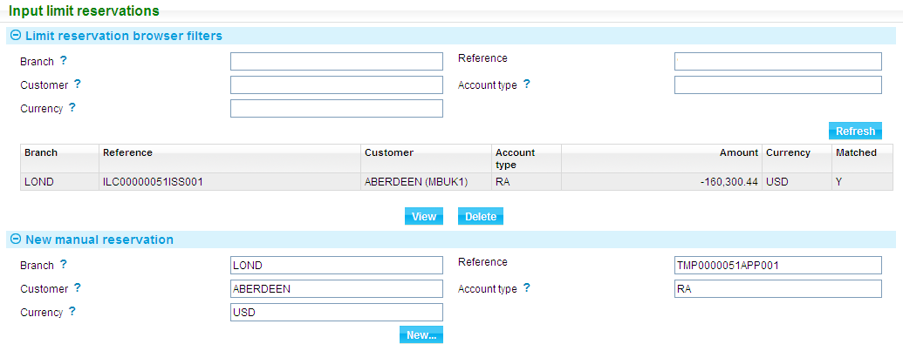

In the window that is displayed you can list reservations already entered on your system, using the filter fields in the usual way. The reservations shown include manually entered reservations and reservations passed to the departmental limits application from the system. Information is shown under the following headings:

|  |  |
| --- | --- |
| Heading | What it Shows |
| Branch | The branch to which the transaction for which the reservation has been entered belongs. |
| Reference | The reference of the transaction for which the reservation has been entered. |
| Customer | The customer the reservation is for. |
| Account Type | The account type of the posting for which the reservation has been made. |
| Amount/Currency | The amount and currency of the reservation. |
| Matched | Indicates whether the reservation has been matched to a posting - in which case the column displays Y - or not. |

The fields in the New Manual Reservation pane are used to enter a new reservation.

Identify the branch, reference, customer, account type and currency of the reservation - all fields in this window are mandatory - then click the **New** button to enter details of the actual reservation.

### Entering Details of the Reservation

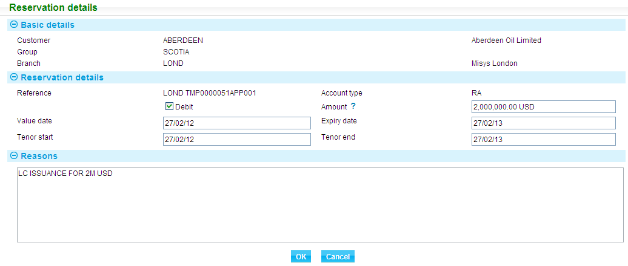

The Basic Details pane shows the unique identifier and country of the customer, their parent customer group, if they have one, and the branch.

The following table explains what to enter into the fields in this window to define the reservation:

|  |  |  |
| --- | --- | --- |
|  | Field | What to Enter |
|  | Debit | Indicates that the reservation involves a debit to the customer's account. |
|  | Amount | The amount of the reservation, in the transaction currency (as defined in the previous window). |
|  | Value Date | The value date of the reservation. |
|  | Expiry Date | The expiry date of the reservation. Reservations that have not been matched when their expiry date is reached are deleted as part of overnight processing. |
|  | Tenor Start | The start date for the tenor period. |
|  | Tenor End | The end date for the tenor period. |
|  | Reason | Free format narrative, explaining the reason for the manual reservation. |

When you click **OK** to save your input, if there is a limit violation, the Limits Affected window is displayed.

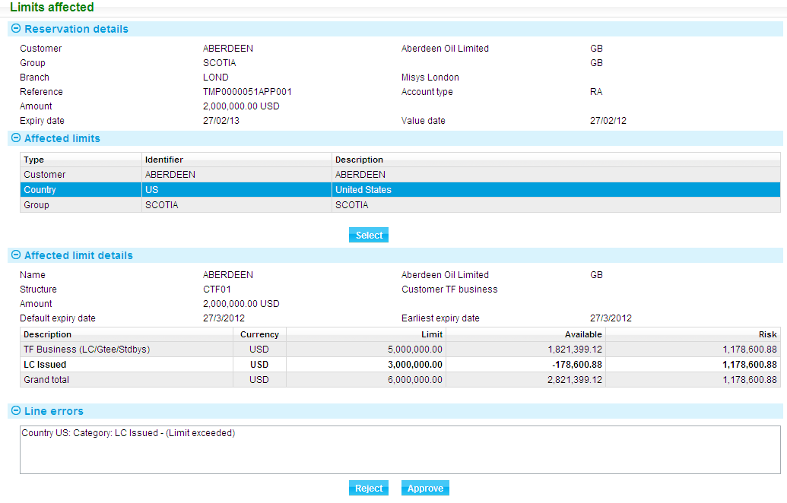

The Reservation Details panel shows the unique identifier and country of the customer and their parent customer group, if they have one, and the branch, together with details of the reservation you have just entered.

The panel in the centre of the window lists the limits that have been affected by this reservation. When you select an entry in this panel, the Affected Customer/Group/Country Details panel shows details of that limit, and lists the categories and total lines affected.

Where a violation has occurred, the line is shown on a shaded background. When you select the line, the Line Errors field will show the violation that occurred.

You can Reject or Approve the Reservation as required

If approved the reservation is displayed as follows:

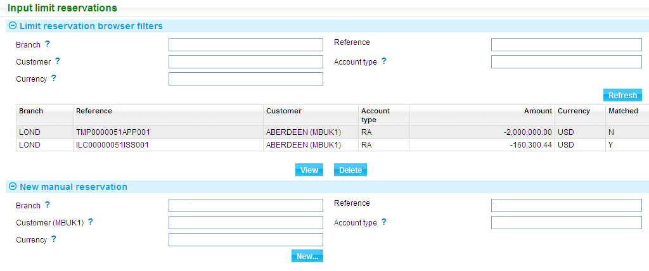

You can View the reservations as follows.

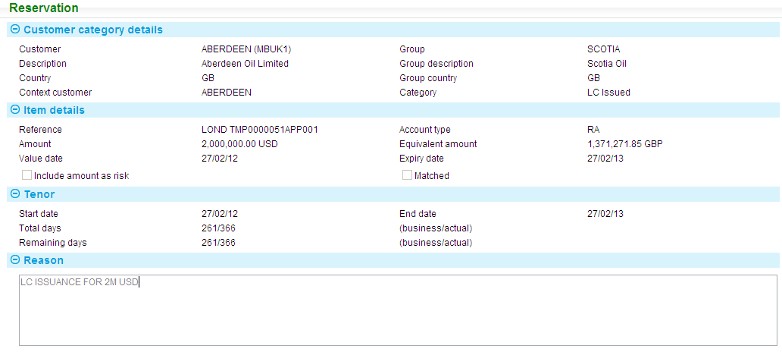

You can delete the reservation by selecting the item from the limit reservation browser and confirming the deletion.

# Enquiries

This chapter covers the enquiry facilities that are delivered with the departmental limits application.

## Starting an Enquiry

To start an enquiry, select the Enquiries|Limit Enquiry menu option.

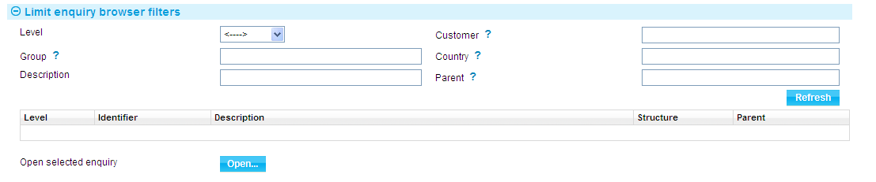

Use the Level field to select whether the enquiry is to be run for customers, for customer groups or for countries. Set the filter fields as required, then click **Refresh**.

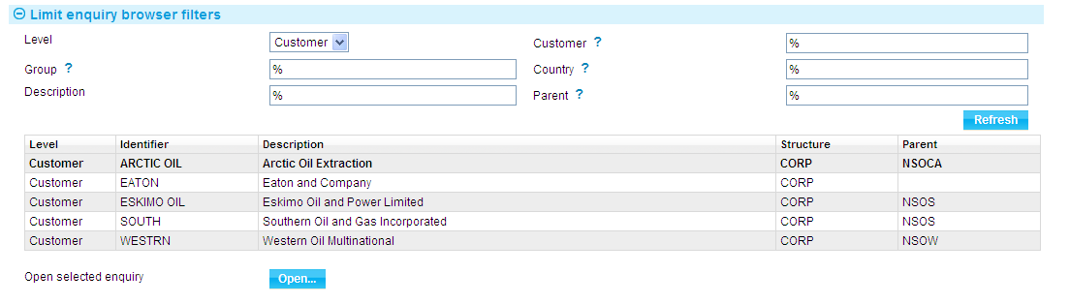

The system displays a list of items. Select the item you wish to enquire upon, then click **Open**. What is displayed next depends on whether the item you opened is a customer, a customer group or a country.

1. When running enquiries, the Close button always takes you back to the previous window.

### For Customers

For customers, the enquiry begins with the Customer Limit Enquiry window (see page 34). From there, you can see further information on the risk categories and total and grand total lines included in the limit structure; and on the individual items recorded for that customer against a risk category.

### For Customer Groups

For customer groups, the enquiry begins with the Customer Group Limit Enquiry window. From there, you can see further information on the risk categories and total and grand total lines included in the limit structure; and on the individual items recorded for that customer group against a risk category.

### For Countries

For countries, the enquiry begins with the Country Limit Enquiry window (see page 34). From there, you can see further information on the risk categories and total and grand total lines included in the limit structure; and on the individual items recorded for that country against a risk category.

## Customer Limit Enquiries

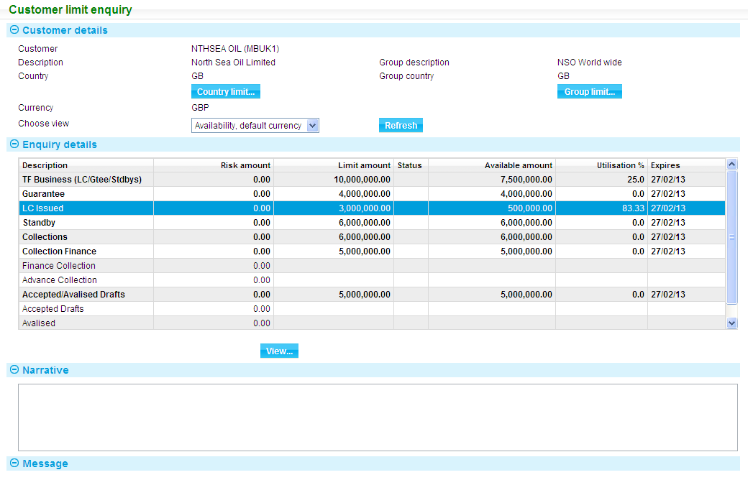

The Customer Limit Enquiry window lists all the risk categories, total lines and grand total lines included in the limit structure for the customer.

The Customer Details pane shows information about the customer, including, if relevant, their country and the customer group to which they belong. If present, the Country Limit button opens the Country Limit Enquiry window (see page 34) for the customer's country; and the Group Limit button opens the Customer Group Limit Enquiry window for the customer group to which the customer belongs.

The Choose View field allows you to select the information to be shown from the following options:

* Availability, default currency
* Exposures, default currency
* Availability, line currency
* Exposures, line currency

Click **Refresh** to activate your selection.

In the Enquiry Details pane lines that involve a limit violation are shown against a highlighted background (the colours used are bank-definable). If you have configured your system to suppress zero lines on enquiries, then lines with zero exposure will not be displayed. Selecting an item and clicking the **View** button allows you to:

View the risk categories included in a total (or grand total) line (see page 35)

View the items contributing to the exposure within a risk category

The Enquiry Details pane shows Availability information under the following headings:

|  |  |
| --- | --- |
| Heading | What it Shows |
| Description | The description given to the risk category or total line. |
| Currency | The line currency. |
| Risk Amount | The weighted exposure set up for the risk category or total line. |
| Limit Amount | The limit set up for the risk category or total line. |
| Status | The status of the risk category or total line. The values shown here will have been devised by your bank.  This field may also show the value of 'X', if the limit is not in the default limit currency. |
| Available Amount | The amount available for utilisation. This is the amount that is used when a limit check or reservation request is received from the system. |
| Utilisation % | The percentage of the limit that has been use for the risk category or total line. |
| Expires | The date the risk category or total line expires. |

It shows Exposures information under the following headings:

|  |  |
| --- | --- |
| Heading | What it Shows |
| Description | The description given to the risk category or total line. |
| Currency | The line currency. |
| Reservations | The net total of all unmatched reservations that are not included in risk against the risk category or total line. |
| Exposures | The current exposure recorded for the risk category or total line. |
| Weighting % | The weighting entered for the risk category, shown as a percentage. |
| Debits | The total of all debits against the risk category or total line. |
| Credits | The total of all credits against the risk category or total line. |

The Narrative pane shows any narrative set up against the limit details for that customer.

The Messages pane provides information concerning the violation.

## Customer Group Limit Enquiries

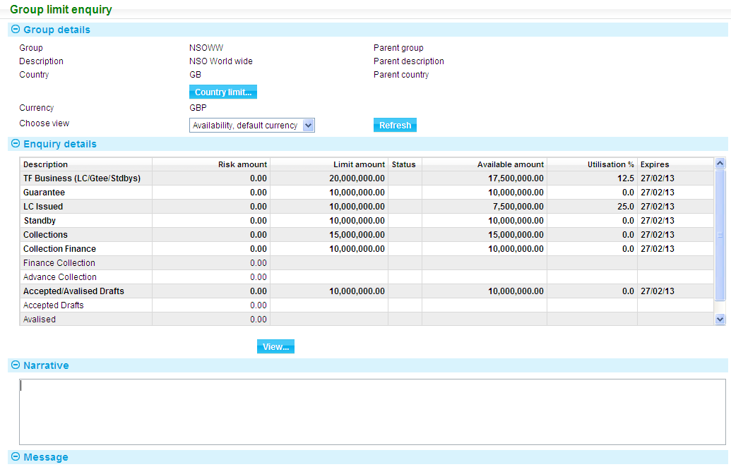

The Group Details pane the customer group's unique identifier, description and country. The same information is shown for the parent customer group, if the customer group has one. The pane also shows the currency of the limit details.

If present, the Country Limit button opens the Country Limit Enquiry window for the customer's country; and the Group Limit button opens the Customer Group Limit Enquiry window for the customer group to which the customer belongs.

The Choose View field allows you to select the information to be shown from the following options:

* Availability, default currency
* Exposures, default currency
* Availability, line currency
* Exposures, line currency

Click **Refresh** to activate your selection.

In the Enquiry Details pane lines that involve a limit violation are shown against a highlighted background (the colours used are bank-definable). If you have configured your system to suppress zero lines on enquiries, then lines with zero exposure will not be displayed. Selecting an item and clicking the **View** button allows you to:

View the risk categories included in a total (or grand total) line (see page 35)

View the items contributing to the exposure within a risk category

The Enquiry Details pane shows Availability information under the following headings:

|  |  |
| --- | --- |
| Heading | What it Shows |
| Description | The description given to the risk category or total line. |
| Currency | The line currency. |
| Risk Amount | The weighted exposure set up for the risk category or total line. |
| Limit Amount | The limit set up for the risk category or total line. |
| Status | The status of the risk category or total line. The values shown here will have been devised by your bank.  This field may also show the value of 'X', if the limit is not in the default limit currency. |
| Available Amount | The amount available for utilisation. This is the amount that is used when a limit check or reservation request is received from the system. |
| Utilisation % | The percentage of the limit that has been use for the risk category or total line. |
| Expires | The date the risk category or total line expires. |

It shows Exposures information under the following headings:

|  |  |
| --- | --- |
| Heading | What it Shows |
| Description | The description given to the risk category or total line. |
| Currency | The line currency. |
| Reservations | The net total of all unmatched reservations that are not included in risk against the risk category or total line. |
| Exposures | The current exposure recorded for the risk category or total line. |
| Weighting % | The weighting entered for the risk category, shown as a percentage. |
| Debits | The total of all debits against the risk category or total line. |
| Credits | The total of all credits against the risk category or total line. |

The Narrative pane shows any narrative set up against the limit details for that customer.

The Messages pane provides information concerning the violation.

## Country Limit Enquiries

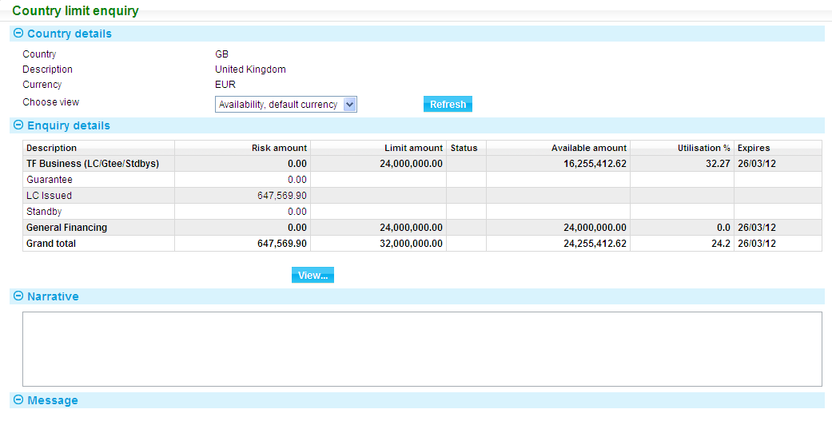

The panel at the top of the window shows the country's unique identifier and description, and the currency of the limit structure.

The Choose View field allows you to select the information to be shown from the following options:

* Availability, default currency
* Exposures, default currency
* Availability, line currency
* Exposures, line currency

Click **Refresh** to activate your selection.

In the Enquiry Details pane lines that involve a limit violation are shown against a highlighted background (the colours used are bank-definable). If you have configured your system to suppress zero lines on enquiries, then lines with zero exposure will not be displayed. Selecting an item and clicking the **View** button allows you to:

* View the risk categories included in a total (or grand total) line (see page 35)
* View the items contributing to the exposure within a risk category

The Enquiry Details pane shows Availability information under the following headings:

| Heading | What it Shows |
| --- | --- |
| Description | The description given to the risk category or total line. |
| Currency | The line currency. |
| Risk Amount | The weighted exposure set up for the risk category or total line. |
| Limit Amount | The limit set up for the risk category or total line. |
| Status | The status of the risk category or total line. The values shown here will have been devised by your bank.  This field may also show the value of 'X', if the limit is not in the default limit currency. |
| Available Amount | The amount available for utilisation. This is the amount that is used when a limit check or reservation request is received from the system. |
| Utilisation % | The percentage of the limit that has been use for the risk category or total line. |
| Expires | The date the risk category or total line expires. |

It shows Exposures information under the following headings:

|  |  |
| --- | --- |
| Heading | What it Shows |
| Description | The description given to the risk category or total line. |
| Currency | The line currency. |
| Reservations | The net total of all unmatched reservations that are not included in risk against the risk category or total line. |
| Exposures | The current exposure recorded for the risk category or total line. |
| Weighting % | The weighting entered for the risk category, shown as a percentage. |
| Debits | The total of all debits against the risk category or total line. |
| Credits | The total of all credits against the risk category or total line. |

The Narrative pane shows any narrative set up against the limit details for that customer.

The Messages pane provides information concerning the violation.

## Viewing Risk Categories within Total Lines

This window lists all the credit risk categories and total lines included in the selected line or total line.

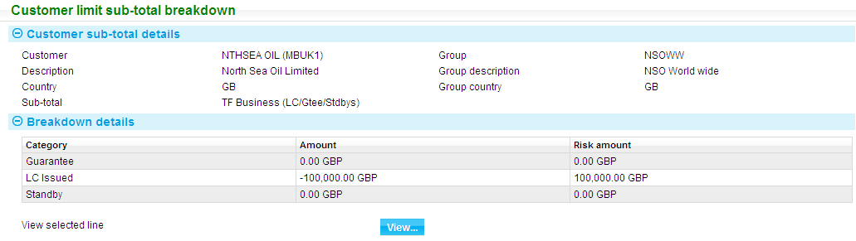

Selecting an item and clicking **View** displays exposure details for that item.

## Viewing Items Contributing to Exposure

Select a risk category (including a category that is part of a total line) and then click the **View** button to list details of all the items contributing to the exposure within that particular category.

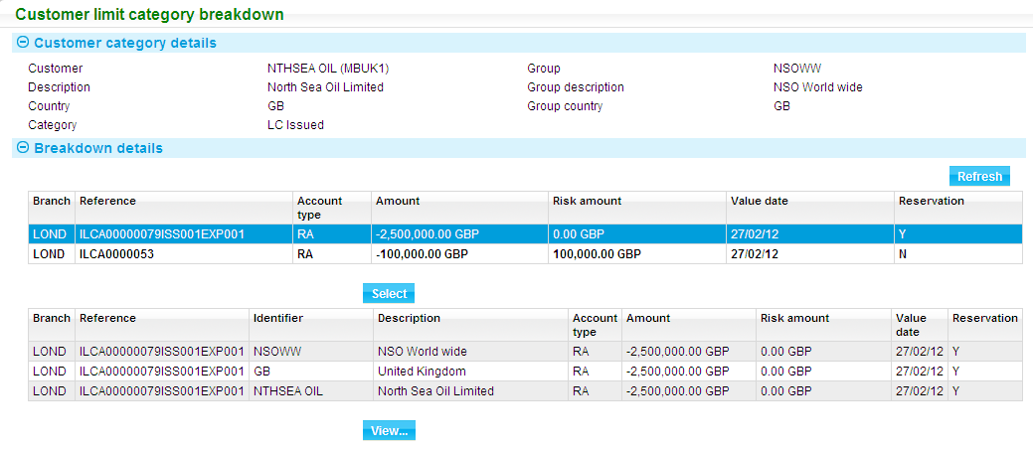

If this window is accessed from within a customer group or country enquiry, the Utilisation button is present and allows you to select an item from the list and then open the Customer Limit Enquiry window (see page 34) for the relevant customer.

Information is shown under the following headings:

|  |  |
| --- | --- |
| Heading | What it Shows |
| Branch | The branch that owns the transaction. |
| Reference | For an exposure item resulting from a released transaction, the transaction's internal master reference. For a reservation, the transaction's internal master reference, plus the reference of the event from which it originated. |
| Account Type | The account type of the reservation or exposure. |
| Amount | The exposure value of the item, and its currency. |
| Risk Amount | The risk associated with item, in the limit currency. |
| Value Date | The value date of the reservation or exposure. |
| Reservation | Indicates whether this is a reservation (Y) or not (N). |

If a line is displayed in bold, this means that the current balance for a given master is displayed. If you highlight an item and click **Select** (or double click on it) the system lists the individual exposure items for the transaction.

You can also highlight an item and click **Select** to list individual exposure items in this way. Once a line is listed in this way you can view details of the individual exposure item by highlighting it and clicking **View**.

## Viewing Exposure Item Details

The window has two layouts, depending on whether the item is an exposure item or a reservation.

### Exposure Items

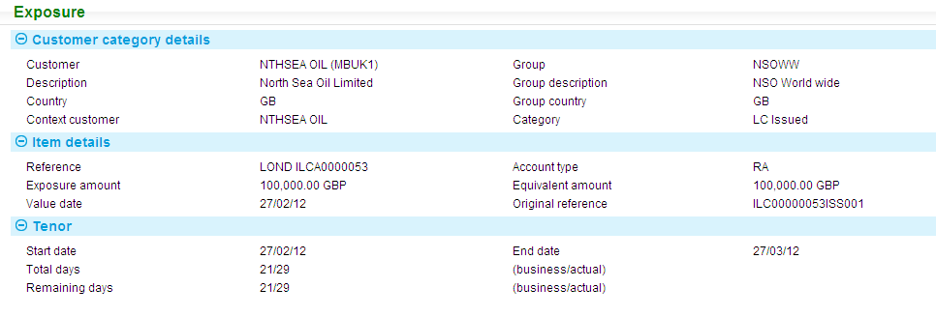

The first pane shows details of the customer and the risk category. The following additional information is shown:

|  |  |
| --- | --- |
| Heading | What it Shows |
| Reference | The master reference and branch of the transaction which created the exposure item. |
| Account Type | The account type associated with the transaction. |
| Amount | The exposure amount or reversing credit amount of the exposure item, in the transaction currency. |
| Equivalent Amount | The amount of the exposure item, in the limit currency. |
| Value Date | The value date of the exposure item. |
| Start Date | The start date for the tenor period. |
| End Date | The end date for the tenor period. |
| Total Days | The number of business days and actual days of the full tenor period. |
| Remaining Days | The number of business days and actual days of the residual tenor period. |

### Reservations

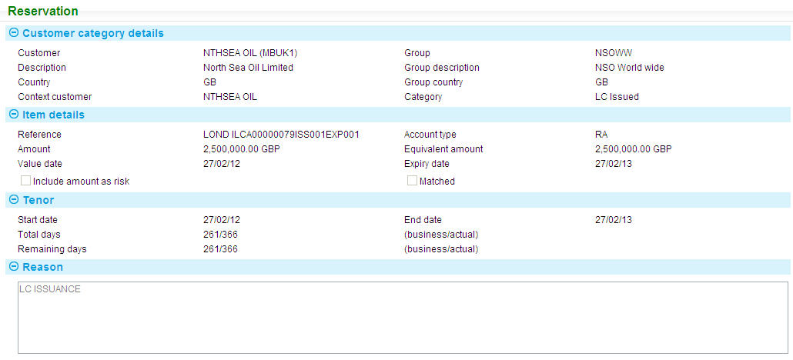

The first pane shows details of the customer and the risk category. The following additional information is shown:

|  |  |
| --- | --- |
| Heading | What it Shows |
| Reference | The master and event reference of the transaction which created the reservation. |
| Account Type | The account type associated with the reservation. |
| Amount | The amount of the reservation, in the transaction currency. |
| Equivalent Amount | The amount of the reservation, in the limit currency. |
| Value Date | The value date of the reservation. |
| Expiry Date | The expiry date of the reservation. This is present only for manually entered reservations. |
| Include amount as Risk | For manually reservations only, indicates whether the reservation amount is considered as risk (Y) or not (N). |
| Matched | Indicates whether the reservation has been matched to an exposure item (Y) or not (N). |
| Start Date | The start date for the tenor period. |
| End Date | The end date for the tenor period. |
| Total Days | The number of business days and actual days of the full tenor period. |
| Remaining Days | The number of business days and actual days of the residual tenor period. |
| Reason | Free format narrative, explaining the reason for the reservation. This is present for manually entered reservations only. |

# Overnight Processing

This chapter describe the overnight processing carried out by the departmental limits application. This includes:

* Recategorisation of exposures, following changes to a limit structure
* Revaluation of exposures, following a change to the spot exchange rates since the previous day
* Deletion of reservations

## General

The Departmental Limits Rebuild process is mapped to start of day. The system stores the current spot rate as the overnight spot rate automatically and uses this rate during the rebuild process.

When the rebuild processing is running, the Departmental Limit service becomes temporarily unavailable until it completes. This means that a user entering a transaction in extended business hours will receive a message indicating that the service is unavailable and must pend their work until the rebuild has completed, at which point they can then continue their work.

A full recategorisation can be requested by setting the *Recategorise all during rebuild* Departmental limit option.

## Recategorisation

Whenever a reservation or exposure is received from the system, it is categorised according to the limits set up for the customer, customer group or country.

If the underlying limit structures are modified, then exposures for all affected customers, customer groups and countries are recategorised during end of day. This process also updates country exposures if you have configured your system not to do so during the day.

If your system is so configured, it also creates default limits for customers for whom no limits have been set up. If new limits are added for a customer, it categorises the postings from existing transactions entered on the database before those limits were added.

The Limit Exception report shows limit violations caused by recategorisation, is produced automatically.

The recategorisation process also removes reconciled exposure items when the balance for a given master reference, customer, branch, currency and account type is zero.

## Revaluation

If the current spot exchange rate for a particular currency has changed since yesterday, then all exposures in that currency are revalued. The current spot exchange rate is then saved and used by the departmental limits application throughout the next day.

The Limit Exception report shows limit violations caused by revaluation is produced automatically.

## Deleting Reservations

During overnight processing, all reservations that have been matched to a posting exposure are deleted, as are any unmatched postings that have reached their expiry date.

A report listing all reservations that have been deleted is produced automatically.

# Appendix - Selection Criteria

This appendix explains the syntax used when setting selection criteria for credit risk categories to determine which transactions belong within a particular credit risk category. It also lists the operators and database fields you can use in selection criteria.

The script language used is JavaScript, and this Appendix assumes a degree of familiarity with JavaScript.

Selection criteria are entered using the Category Details window. See Chapter 4 for instructions on how to get to this window and what to enter into it.

The selection criteria entered will become part of a JavaScript function, which is generated as part of the categorisation process. The purpose of the generated function is to return a 'true' or 'false' value using the field 'selected'. By default the value of the 'selected' field is set to false.

## Constructing an 'if' Statement

Selection criteria are entered into the Criteria field, and are constructed as a series of 'if' statements which have the following structure:

if (your selection criteria here) {

selected = true; (or false)

}

If a comparison is made to a fixed string value, then double quotes must be used to enclose the string, as in the following example:

if (Transaction.accountType == "RA"){

selected = true;

}

Your selection can be continued on multiple lines without the need to have a special continuation character. For example:

if (Transaction.accountType == "RA" ||

Transaction.accountType == "RB"){

selected = true;

}

Comments can be entered by preceding them with a double forward slash (//). This signals that the remainder of the line is a comment. For example:

// Some comments

//

if (Transaction.accountType == "RA" ||

Transaction.accountType == "RB"){

selected = true;

}

If you use more than one selection criterion, then you must specify whether they are 'and' or 'or' criteria. You can have all 'and' criteria, all 'or' criteria or a mixture of 'and' and 'or' criteria.

If all the criteria you set up are 'and' criteria, then each one of them must be met for the transaction to be included in the credit risk category.

If all the criteria you set up are 'or' criteria, then any one of them that is met causes the transaction to be included in the credit risk category.

For mixed criteria, you can use brackets to specify complex criteria. If you do not set up any brackets yourself, the system evaluates the criteria from left to right, as shown in the following examples.

If you set up four criteria in the following way:

if (Transaction.accountType == "RA" ||

Transaction.accountType == "RB" &&

Transaction.accountType == "RC"){

selected = true;

}

where:

|| means OR

&& means AND

the system creates the following formula for evaluation:

((accountType == “RA || accountType == "RB") && accountType == RC))

Either of the first two criteria plus the last criterion must be met for the transaction to be included in the credit risk category.

There are two groups of database fields available for constructing your selection criteria:

* Customer fields prefixed by Customer
* Transaction fields prefixed by Transaction

### Validating your Input

When you have entered your selection criteria script, click the **Validate** button. This will check the syntax of your JavaScript.

The most common cause of validation errors are listed below.

Case sensitivity issues such as using “If” rather than “if”, “customer” rather than “Customer” or “True” rather than “true”.

Forgetting the brackets around the if condition.

Forgetting to put “{“ and “}“ where required.

Spelling mistakes in the database objects or fields. For example. using “slected” rather than “selected” or “Cstomer” rather than “Customer” and so on.

Using single “=” rather than “==” in your “if” condition. The double equals operator “==” is required for comparison and the single “=” for assignment.

### Operators and Database Fields

You can use the following operators when constructing selection criteria:

|  |  |
| --- | --- |
| == | (equal to) |
| != | (not equal to) |
| < | (less than) |
| <= | (less than or equal) |
| > | (greater than) |
| >= | (greater than or equal) |
| || | (or) |
| && | (and) |

The database fields available are in two groups - customer fields and transaction fields. The following fields can be used when constructing selection criteria:

|  |  |
| --- | --- |
| Customer.identifier | The customer's unique identifier. |
| Customer.customerType | The customer type. |
| Customer.accountOfficer | The customer's account officer. |
| Customer.analysisCode | The customer analysis code. |
| Customer.parentCountry | The customer's parent country. |
| Customer.residenceCountry | The customer's residence country. |
| Customer.residenceCountryTenor | The tenor assigned to the customer's residence country. This can be used in comparisons against the transaction tenor. |
| Customer.riskCountry | The customer's risk country. |
| Customer.riskCountryTenor | The tenor of the customer's risk country. This can be used in comparisons against the transaction tenor. |
| Transaction.accountType | The transaction's account type. |
| Transaction.currency | The transaction's currency. |
| Transaction.fullTenorActual | The full tenor of the transaction in calendar days. |
| Transaction.fullTenorBusiness | The full tenor of the transaction in business days. |
| Transaction.contingent | A Y/N flag used to indicate whether the transaction is contingent or not. |
| Transaction.residualTenorActual | The residual tenor of the transaction in calendar days. |
| Transaction.residualTenorBusiness | The residual tenor of the transaction in business days. |

#### Tenor Fields

The difference between actual tenor and residual tenor is that, if actual tenor is used to categorise a transaction, then, once categorised, an exposure will remain in the same category unless an amendment that changes the tenor period is received from the system.

If residual tenor is used, overnight processing will check the remaining number of days in the tenor period and move the exposure to 'shorter' risk categories as the end of the tenor period draws closer, causing the exposure to fall into different categories.